San Jose State University

EE250 (Section 2) Fall 2019 Prof. Kamali

Solution to Problem Set #2

- Problem 3.13
a) 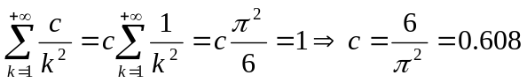
b) 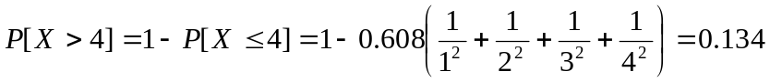
c)

- Problem 3.17
a) 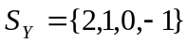
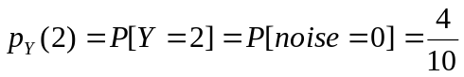
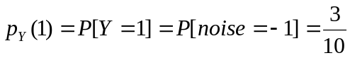
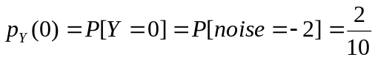
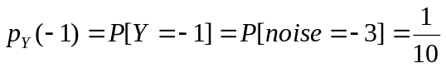
b) 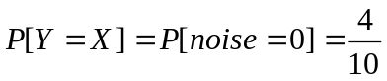
c) 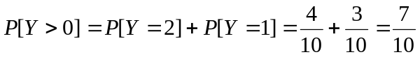

- Problem 3.31
a) 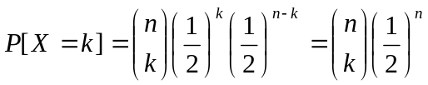
Expected Reward:

In the course we have found the first and second moments of the Binomial RV.

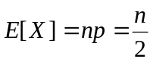, 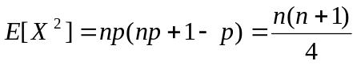
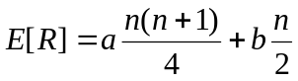
Expected Net Reward: 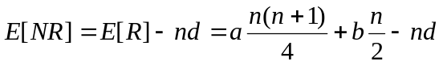

b)

4. [Midterm, Spring 2009] The probability mass function (pmf) of the discrete random variable  is given as follows.

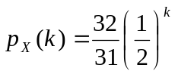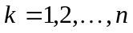

- Find .
- Find 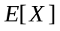 and 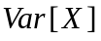.

Solution:
a) 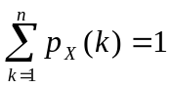
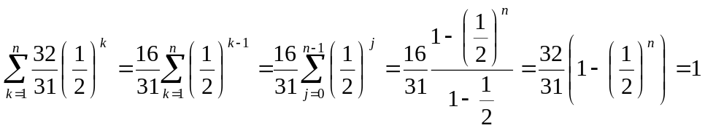

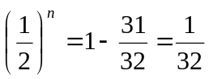

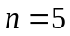

b) 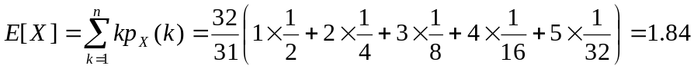

- [Midterm, Spring 2009] The life time of two electronic components follow a Geometric random variable with the same parameter. Find the probability that one lives longer than the other.

Hint: 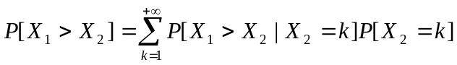

Solution:

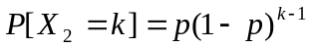

- [Midterm, Fall 2010] Suppose and are two independent geometric random variables with parameters 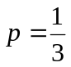and 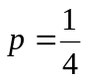, respectively. Find 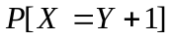.
Solution:

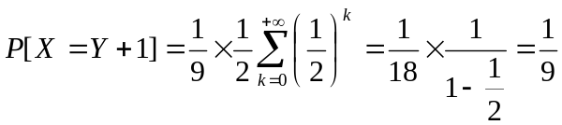
- [Midterm, Spring 2014] The pmf of a discrete random variable 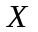is shown in the following figure.

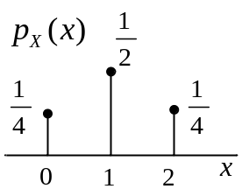

- Find and plot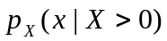.
- Find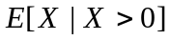.

Solution:
- 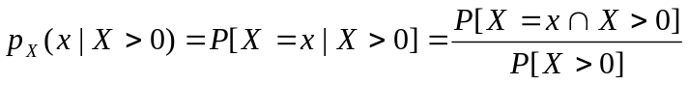

Clearly 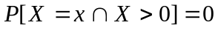for 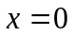. For 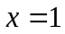and 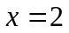,

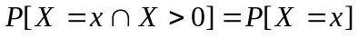

Furthermore 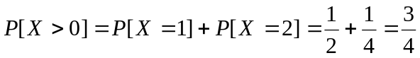. Thus
, 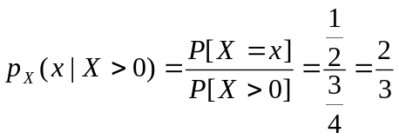
, 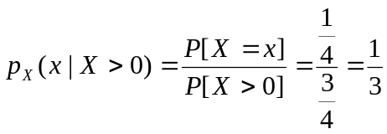
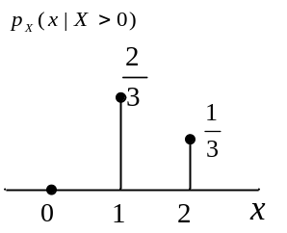

- 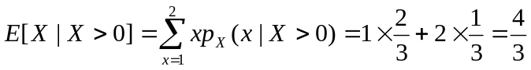

- [Midterm, Fall 2015] A train shuttles between stations A and B (no station in between). The number of commuters that get on board in station A follows a Poisson distribution with parameter. With probability of , a controller also boards the train in station A to check people’s ticket. Everyone (including the controller) get off the train in station B. Let us denote by 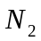the pmf of the number of people leaving the train in station B.

- Find 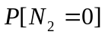.
- Find 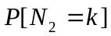 for 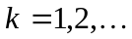.

Solution:

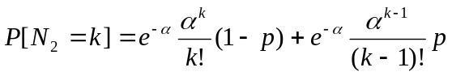

- Problem 3.57
The distribution of green bits, red bits, and raisins in 1/12th of a slice is Poisson with 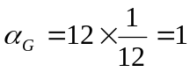, 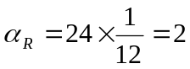, and 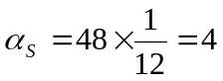. Note that they are independent.

a) 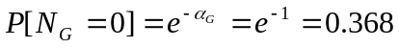
b)

c)
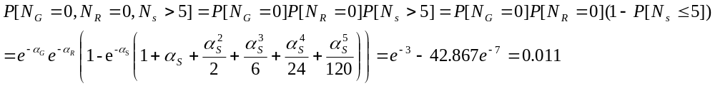

- [Midterm Fall 2005] The number of cars passing through a junction in one minute is a Poisson random variable with parameter 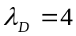if it is a weekday and 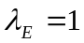if it is a weekend. An old mathematician sitting in a nursing home watching the junction wants to detect whether it is a weekday or weekend by counting the number of cars passing through it.

- Find 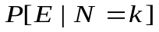 and 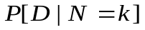whereandare the weekend and week day events, respectively andis the number of cars in one minute.
- The mathematician observes the numbers of cars passing through the junction in a minute and uses the following detection rule.

If, it is a week day. Otherwise it is a weekend.

Using this detection rule, find out what is detected (weekend or week day) when different values of is observed, e.g., you need to find out what is detected (weekend or week day) when k=0 is observed and what is detected when k=1 is observed, etc.

c) Find the probability of error of the detection rule that the old mathematician uses.

Solution:
- Using Bayes’ rule
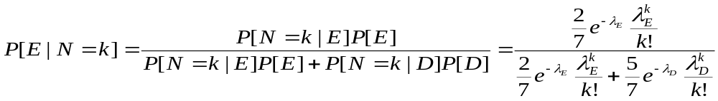
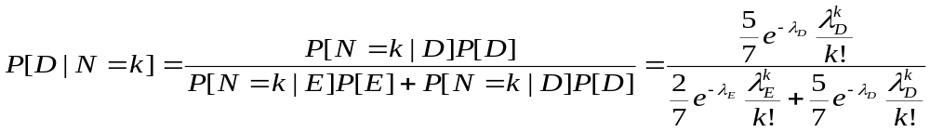
b) leads to

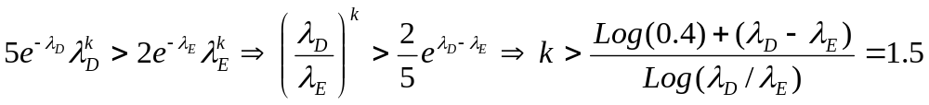
Thus weekend is detected if 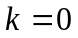or 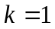and week day is detected if 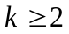.

c)
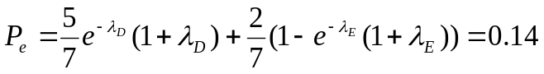

- Find the probability that two Poisson RVs with 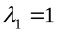 and 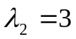 are equal?

Solution:

The above infinite sum has no closed form solution. So we approximate it with the following finite sum.

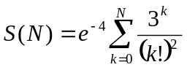

The following graph shows 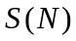vs. .

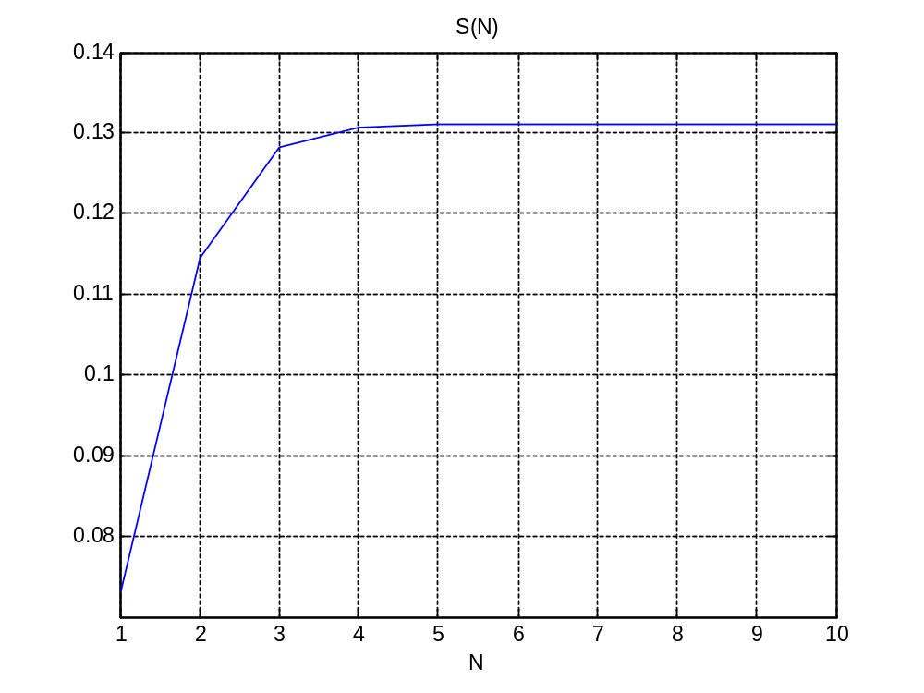

As the Figure shows, does not change much for 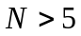 and as such

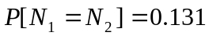

- [Midterm, Fall 2014] Suppose 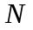is a Poisson random variable with parameter 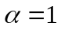. Find 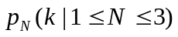.

Solution:
Clearly 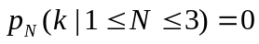for and 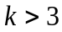. For 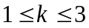, we have

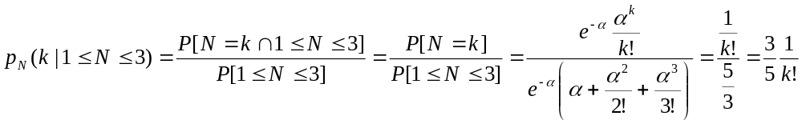

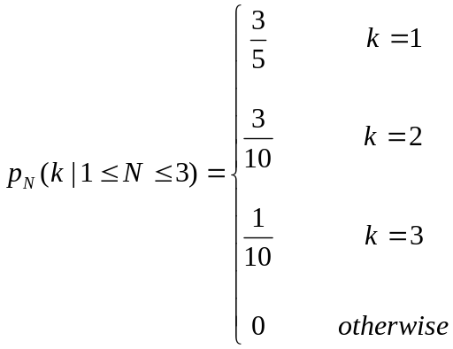

- [Midterm, Spring 2015] A hitchhiker monitoring the cars passing him in the highway realizes that the average number of cars passing him in 10 seconds is 1 in one direction and 2 in the other direction. Assuming that the number of cars passing him in 10 seconds follows a Poisson random variable, find the probability that a total of two cars pass him by in 10 seconds (in both directions). You may assume that the numbers of cars passing in the two directions are independent of each other.

Solution:
If 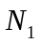andare the number of cars passing in the two directions, we want to find 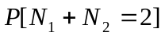.

Due to the independence of and,

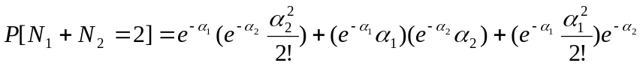

Assuming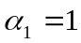and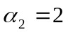, we have

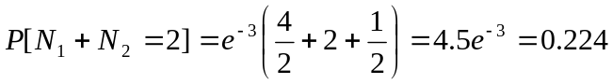

In fact it can be proven that when andare independent, 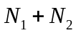is also Poisson with 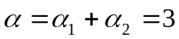and thus

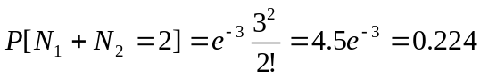

- [Midterm, Fall 2017] The number of packets arriving at a multiplexer is a Poisson random variable. A graduate student has written a code that records the number of packets that arrive at this multiplexer over many one microsecond intervals. The code shows that in two third of these one microsecond intervals, at least one packet arrives at the multiplexer. What is the average number of packets that arrive at the multiplexer in one microsecond?

Solution:

